**Institute of Computer Technology**

**B. Tech. Computer Science and Engineering**

**Semester: III**

**Sub: Database Management System**

**Course Code: 2CSE301**

**Practical Number:8**

**Objective:**

*Actor Table*

**Queries:**

1. **Create a view to store all information of the actors whose name starts with ‘A’ and last name contains ‘A’. Verify whether the view is created or not by displaying all the data from view.**

**Code :**

CREATE VIEW actor_name AS SELECT `first_name` FROM actor WHERE `first_name` LIKE"A%";

**Output :**

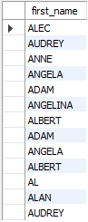

1. **Create a view which displays the actor table in the descending order of their last name.**

**Code :**

CREATE VIEW actor2 AS SELECT * FROM actor ORDER BY actor.last_name DESC;

**Output :**

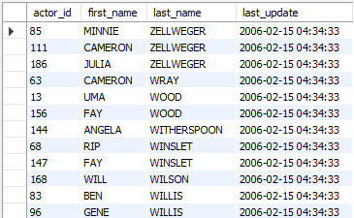

1. **Delete the above created view.**

**Code :**

DROP VIEW actor_name;

**Output :**



**Objective:**

*Actor Table*

1. **Create a view to display language id, name and last update.**

**Code :**

CREATE VIEW language1 AS SELECT * FROM language;

**Output :**



1. **Insert following record with name and last update in the view, also verify whether it has been inserted in base table or not**

**(‘Hindi’, ‘2013-07-05 ‘12:23:05’).**

**Code :**

INSERT INTO language1 VALUES (7,'Hindi','2013-07-05 12:23:05');

**Output :**



1. **Update the language of the newly inserted record to ‘Spanish’ and verify whether it has been updated in the base table or not.**

**Code :**

UPDATE language1 SET `name` = 'Spanish' WHERE `language_id` =7;

**Output :**



1. **Delete the record of Spanish Language and verify whether it has been deleted from the base table or not.**

**Code :**

DELETE FROM language1 WHERE `language_id`=7;

**Output :**



1. **Create a view which stores language id, name and last update for those records which are last updated on ‘2006-02-15 05:02:19’ with check option.**

**Code :**

CREATE VIEW language2 AS SELECT * FROM language WHERE last_update = '2006-02-15 05:02:19';

**Output :**



1. **Insert a new record with language Hindi and last update as**

**‘2020-07-13 10:00:19’ and verify whether it has been inserted or not.**

**Code :**

INSERT INTO language2 VALUES (9,'Hindi','2020-07-13 10:00:19');

**Output :**



1. **Insert a new record with language Hindi and last update as**

**‘2006-02-15 05:02:19’ and verify whether it has been inserted or not?**

**Code :**

INSERT INTO language2 VALUES (8,'Hindi','2006-02-15 05:02:19');

**Output :**



1. **Update the newly inserted record with last update as**

**‘2020-07-13 10:00:19’ andverify whether it has been updated or not?**

**Code :**

UPDATE language2 SET last_update = '2020-07-13 10:00:19' WHERE `language_id`=8;

**Output :**

